Word Volume Control Knob*
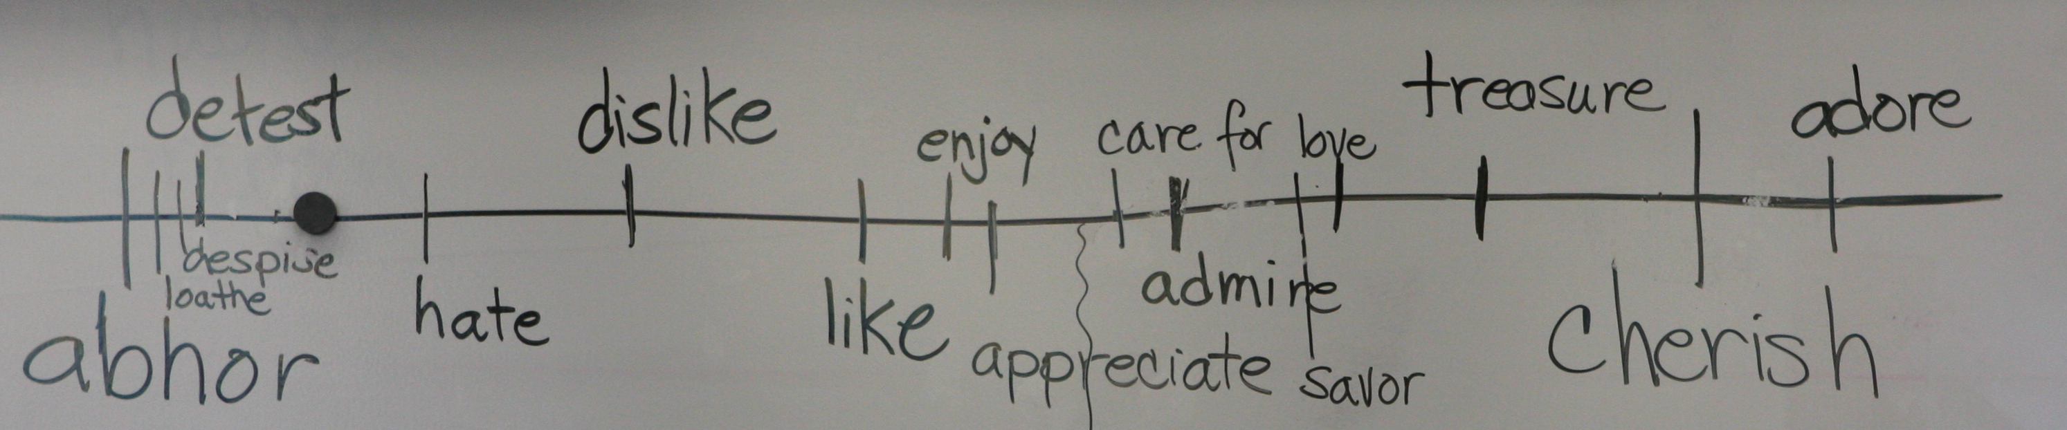
Brainstorm and record where different degrees of an original given word might be placed on a word continuum (see above). It works as a thesaurus and gives both antonyms and synonyms for a central word.

An option for after the continuum is created: Give examples of situations – ask students which word on the continuum best applies to the situation – and place the “control knob” (large magnet) in the correct location (i.e.: What word describe how I feel about spiders crawling over me? – possible response is “despise” – student puts magnet near this word)
Thinking moves: discover and explore nuance – meaning of different related words

The Connection Game*

Look carefully – can you make connections? What is the relationship between two people, things, ideas or concepts in the image? What is the connection?

Thinking moves: make comparisons, think metaphorically, synthesize, discover the essence, find significance, and demonstrate evidential reasoning
*Created by Joni Chancer

